CHAPTER 1

1.1 For body weight:

TW = 1.5%

For total body water:

IW = 55%

1.2


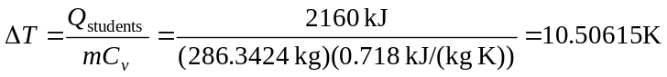

Therefore, the final temperature is 20 + 10.50615 = 30.50615ºC.

1.3 This is a transient computation. For the period from ending June 1:

Balance = Previous Balance + Deposits – Withdrawals

Balance = 1512.33 + 220.13 – 327.26 = 1405.20

The balances for the remainder of the periods can be computed in a similar fashion as tabulated below:

Date | Deposit | Withdrawal | Balance
1-May |  |  | $ 1512.33
 | $ 220.13 | $ 327.26
1-Jun |  |  | $ 1405.20
 | $ 216.80 | $ 378.61
1-Jul |  |  | $ 1243.39
 | $ 450.25 | $ 106.80
1-Aug |  |  | $ 1586.84
 | $ 127.31 | $ 350.61
1-Sep |  |  | $ 1363.54

1.4 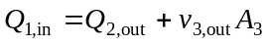

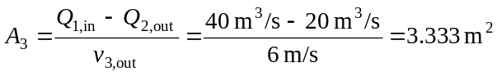

1.5 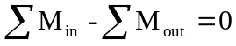

1.6 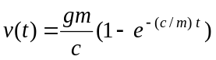

jumper #1: 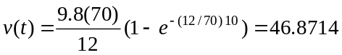

jumper #2: 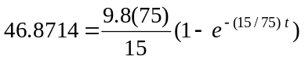

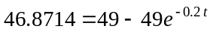

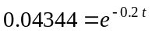

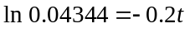

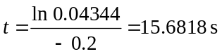

1.7 You are given the following differential equation with the initial condition, v(t = 0) = v(0),

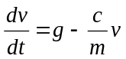

The most efficient way to solve this is with Laplace transforms

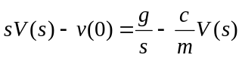

Solve algebraically for the transformed velocity

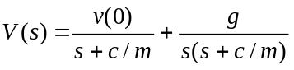 (1)

The second term on the right of the equal sign can be expanded with partial fractions

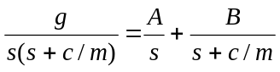

Combining the right-hand side gives

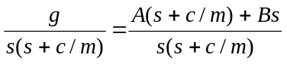

By equating like terms in the numerator, the following must hold

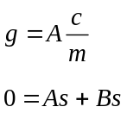

The first equation can be solved for A = mg/c. According to the second equation, B = –A. Therefore, the partial fraction expansion is

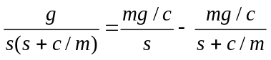

This can be substituted into Eq. 1 to give

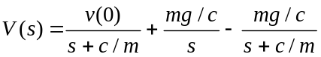

Taking inverse Laplace transforms yields

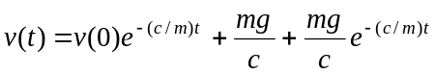

or collecting terms

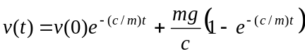

The first part is the general solution and the second part is the particular solution for the constant forcing function due to gravity.

1.8 At t = 10 s, the analytical solution is 44.87 (Example 1.1). The relative error can be calculated with

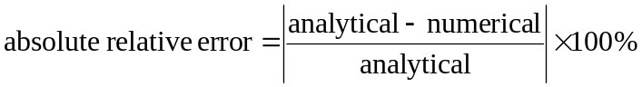

The numerical results are:

step | v(10) | absolute  relative error
2 | 47.9690 | 6.90%
1 | 46.3639 | 3.32%
0.5 | 45.6044 | 1.63%

The error versus step size can then be plotted as

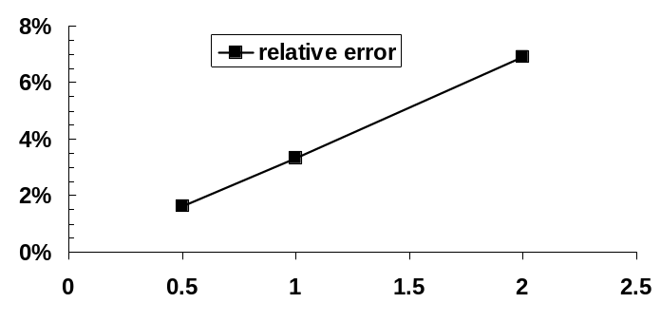

Thus, halving the step size approximately halves the error.

1.9 (a) You are given the following differential equation with the initial condition, v(t = 0) = 0,

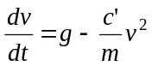

Multiply both sides by m/c′

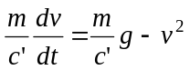

Define 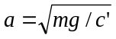

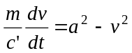

Integrate by separation of variables,

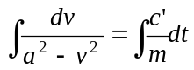

A table of integrals can be consulted to find that

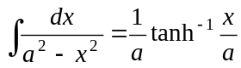

Therefore, the integration yields

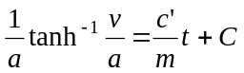

If v = 0 at t = 0, then because tanh^{–1}(0) = 0, the constant of integration C = 0 and the solution is

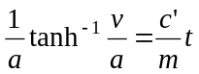

This result can then be rearranged to yield

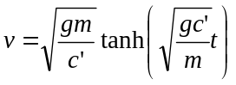

(b) Using Euler’s method, the first two steps can be computed as

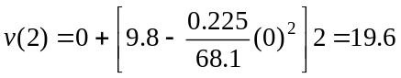

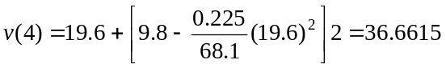

The computation can be continued and the results summarized and plotted as:

t | v | dv/dt
0 | 0 | 9.8
2 | 19.6 | 8.53075
4 | 36.6615 | 5.35926
6 | 47.3800 | 2.38305
8 | 52.1461 | 0.81581
10 | 53.7777 | 0.24479
12 | 54.2673 | 0.07002
∞ | 54.4622

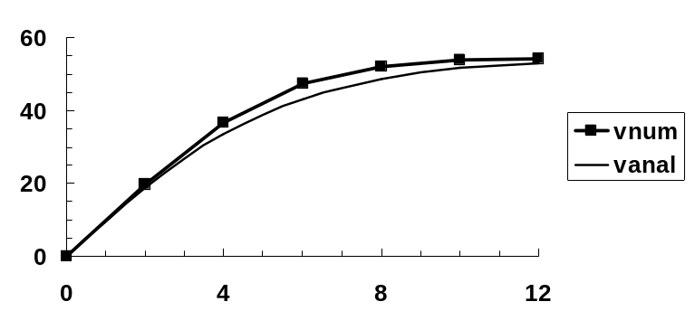

Note that the analytical solution is included on the plot for comparison.

1.10 Before the chute opens (t < 10), Euler’s method can be implemented as

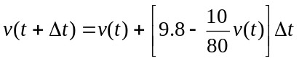

After the chute opens (t ≥ 10), the drag coefficient is changed and the implementation becomes

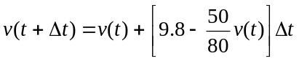

Here is a summary of the results along with a plot:

Chute closed |  |  | Chute opened
t | v | dv/dt | t | v | dv/dt
0 | -20.0000 | 12.3000 | 10 | 52.5134 | -23.0209
1 | -7.7000 | 10.7625 | 11 | 29.4925 | -8.6328
2 | 3.0625 | 9.4172 | 12 | 20.8597 | -3.2373
3 | 12.4797 | 8.2400 | 13 | 17.6224 | -1.2140
4 | 20.7197 | 7.2100 | 14 | 16.4084 | -0.4552
5 | 27.9298 | 6.3088 | 15 | 15.9531 | -0.1707
6 | 34.2385 | 5.5202 | 16 | 15.7824 | -0.0640
7 | 39.7587 | 4.8302 | 17 | 15.7184 | -0.0240
8 | 44.5889 | 4.2264 | 18 | 15.6944 | -0.0090
9 | 48.8153 | 3.6981 | 19 | 15.6854 | -0.0034
 |  |  | 20 | 15.6820 | -0.0013

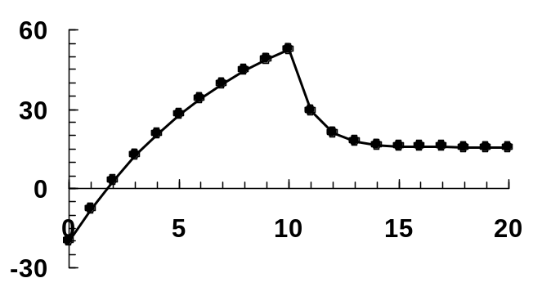

1.11 (a) The force balance can be written as:

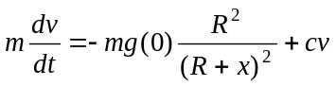

Dividing by mass gives

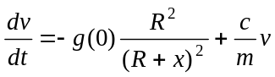

(b) Recognizing that dx/dt = v, the chain rule is

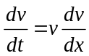

Setting drag to zero and substituting this relationship into the force balance gives

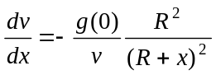

(c) Using separation of variables

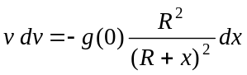

Integrating gives

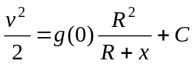

Applying the initial condition yields

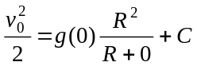

which can be solved for C = v₀²/2 – g(0)R, which can be substituted back into the solution to give

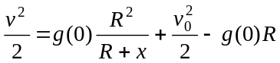

or

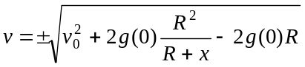

Note that the plus sign holds when the object is moving upwards and the minus sign holds when it is falling.

(d) Euler’s method can be developed as

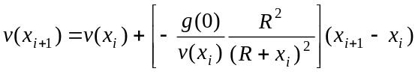

The first step can be computed as

The remainder of the calculations can be implemented in a similar fashion as in the following table

x | v | dv/dx | v-analytical
0 | 1400.000 | -0.00700 | 1400.000
10000 | 1330.000 | -0.00735 | 1328.272
20000 | 1256.547 | -0.00775 | 1252.688
30000 | 1179.042 | -0.00823 | 1172.500
40000 | 1096.701 | -0.00882 | 1086.688
50000 | 1008.454 | -0.00957 | 993.796
60000 | 912.783 | -0.01054 | 891.612
70000 | 807.413 | -0.01188 | 776.473
80000 | 688.661 | -0.01388 | 641.439
90000 | 549.864 | -0.01733 | 469.650
100000 | 376.568 | -0.02523 | 174.033

For the analytical solution, the value at 10,000 m can be computed as

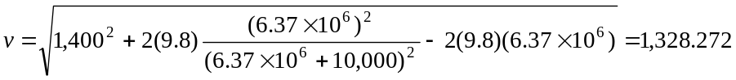

The remainder of the analytical values can be implemented in a similar fashion as in the last column of the above table. The numerical and analytical solutions can be displayed graphically.

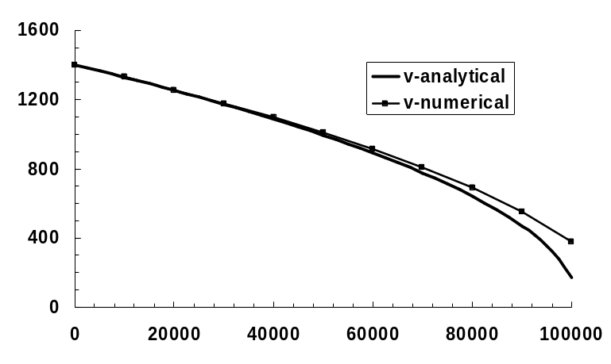

1.12 (a) The first two steps are

The process can be continued to yield

t | c | dc/dt
0 | 10.0000 | -2.0000
0.1 | 9.8000 | -1.9600
0.2 | 9.6040 | -1.9208
0.3 | 9.4119 | -1.8824
0.4 | 9.2237 | -1.8447
0.5 | 9.0392 | -1.8078
0.6 | 8.8584 | -1.7717
0.7 | 8.6813 | -1.7363
0.8 | 8.5076 | -1.7015
0.9 | 8.3375 | -1.6675
1 | 8.1707 | -1.6341

(b) The results when plotted on a semi-log plot yields a straight line

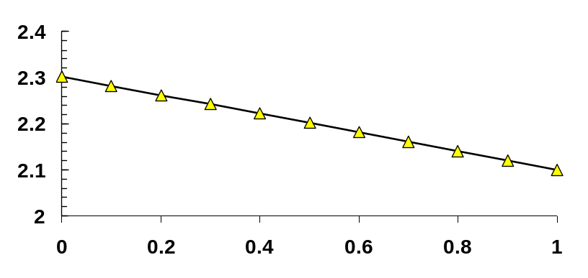

The slope of this line can be estimated as

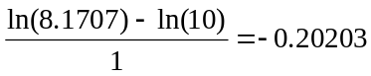

Thus, the slope is approximately equal to the negative of the decay rate.

1.13 The first two steps yield

The process can be continued to give

t | y | dy/dt | t | y | dy/dt
0 | 0.00000 | -0.41667 | 5.5 | 1.27629 | 0.20557
0.5 | -0.20833 | -0.12936 | 6 | 1.37907 | -0.31908
1 | -0.27301 | 0.46843 | 6.5 | 1.21953 | -0.35882
1.5 | -0.03880 | 0.82708 | 7 | 1.04012 | 0.12287
2 | 0.37474 | 0.61686 | 7.5 | 1.10156 | 0.68314
2.5 | 0.68317 | 0.03104 | 8 | 1.44313 | 0.80687
3 | 0.69869 | -0.39177 | 8.5 | 1.84656 | 0.38031
3.5 | 0.50281 | -0.26286 | 9 | 2.03672 | -0.20436
4 | 0.37138 | 0.29927 | 9.5 | 1.93453 | -0.40961
4.5 | 0.52101 | 0.77779 | 10 | 1.72973 | -0.04672
5 | 0.90991 | 0.73275

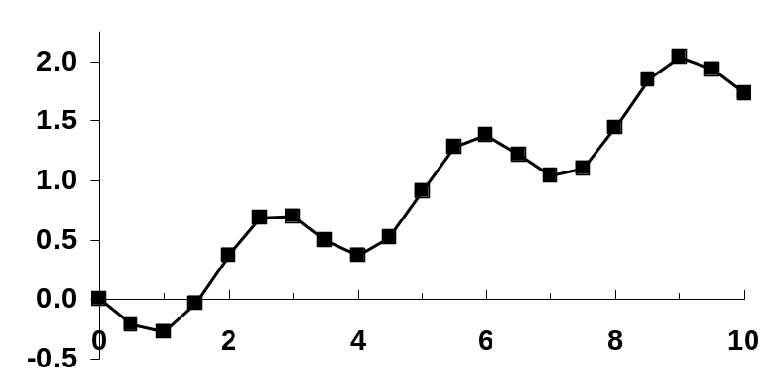

1.14 The first two steps yield

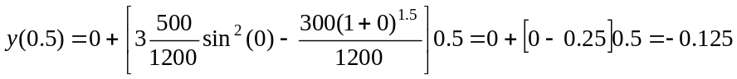

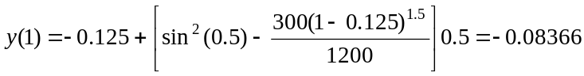

The process can be continued to give

t | y | dy/dt
0 | 0.00000 | -0.25000
0.5 | -0.12500 | 0.08269
1 | -0.08366 | 0.66580
1.5 | 0.24924 | 0.89468
2 | 0.69658 | 0.48107
2.5 | 0.93711 | -0.22631
3 | 0.82396 | -0.59094
3.5 | 0.52849 | -0.31862
4 | 0.36918 | 0.31541
4.5 | 0.52689 | 0.72277
5 | 0.88827 | 0.50073
5.5 | 1.13864 | -0.15966
6 | 1.05881 | -0.64093
6.5 | 0.73834 | -0.51514
7 | 0.48077 | 0.08906
7.5 | 0.52530 | 0.62885
8 | 0.83973 | 0.59970
8.5 | 1.13958 | 0.01457
9 | 1.14687 | -0.57411
9.5 | 0.85981 | -0.62702
10 | 0.54630 | -0.11076

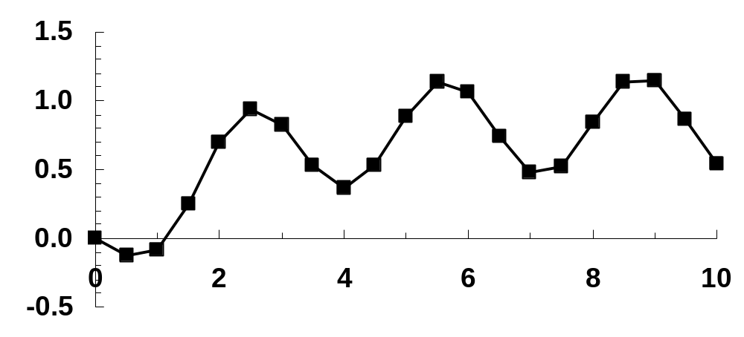

1.15 The volume of the droplet is related to the radius as

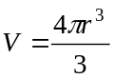 (1)

This equation can be solved for radius as

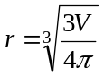 (2)

The surface area is

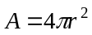 (3)

Equation (2) can be substituted into Eq. (3) to express area as a function of volume

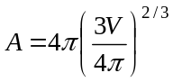

This result can then be substituted into the original differential equation,

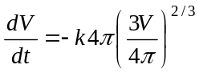 (4)

The initial volume can be computed with Eq. (1),

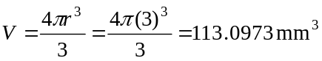

Euler’s method can be used to integrate Eq. (4). Here are the beginning and last steps

t | V | dV/dt
0 | 113.0973 | -11.3097
0.25 | 110.2699 | -11.1204
0.5 | 107.4898 | -10.9327
0.75 | 104.7566 | -10.7466
1 | 102.07 | -10.5621
•
•
•
9 | 38.29357 | -5.49416
9.25 | 36.92003 | -5.36198
9.5 | 35.57954 | -5.2314
9.75 | 34.27169 | -5.1024
10 | 32.99609 | -4.97499

A plot of the results is shown below:

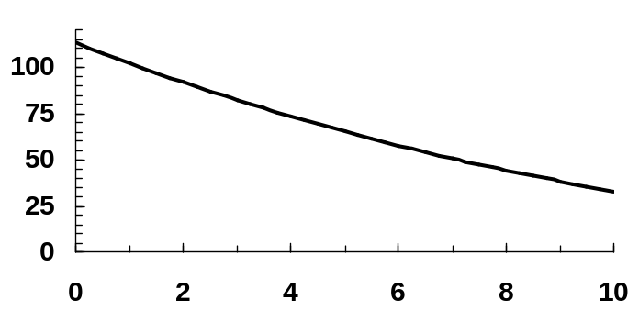

Eq. (2) can be used to compute the final radius as

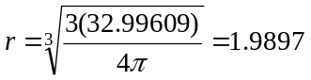

Therefore, the average evaporation rate can be computed as

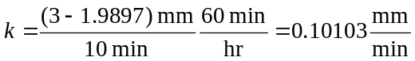

which is approximately equal to the given evaporation rate.

1.16 The first two steps can be computed as

The remaining results are displayed below along with a plot

t | T | dT/dt
0 | 68.00000 | -0.79900
1 | 67.20100 | -0.78542
2 | 66.41558 | -0.77206
3 | 65.64352 | -0.75894
4 | 64.88458 | -0.74604
5 | 64.13854 | -0.73336
6 | 63.40519 | -0.72089
7 | 62.68430 | -0.70863
8 | 61.97566 | -0.69659
9 | 61.27908 | -0.68474
10 | 60.59433 | -0.67310

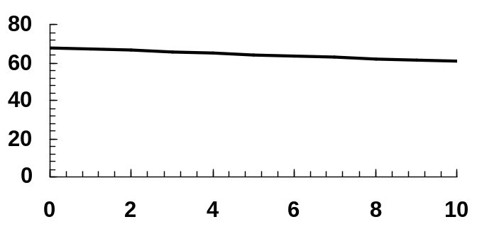

1.17 (a) The solution of the differential equation is

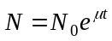

The doubling time can be computed as the time when N = 2N₀,

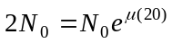

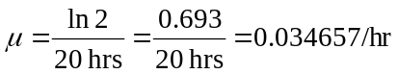

(b) The volume of an individual spherical cell is

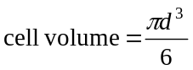 (1)

The total volume is

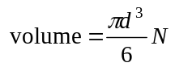 (2)

The rate of change of N is defined as

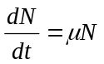 (3)

If N = N₀ at t = 0, Eq. 3 can be integrated to give

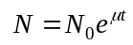 (4)

Therefore, substituting (4) into (2) gives an equation for volume

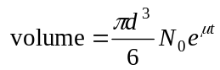 (5)

(c) This equation can be solved for time

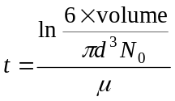 (6)

The volume of a 500 μm diameter tumor can be computed with Eq. 2 as 65,449,847. Substituting this value along with d = 20 μm, N₀ = 1 and μ = 0.034657/hr gives

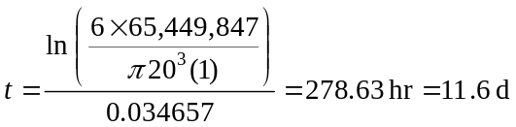 (6)

1.18 Continuity at the nodes can be used to determine the flows as follows:

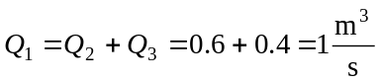

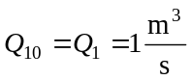

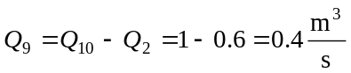

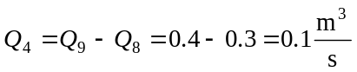

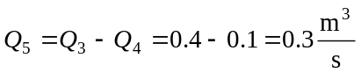

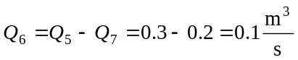

Therefore, the final results are

